Exercise 3: Assertions in JUnit

Pop.xml

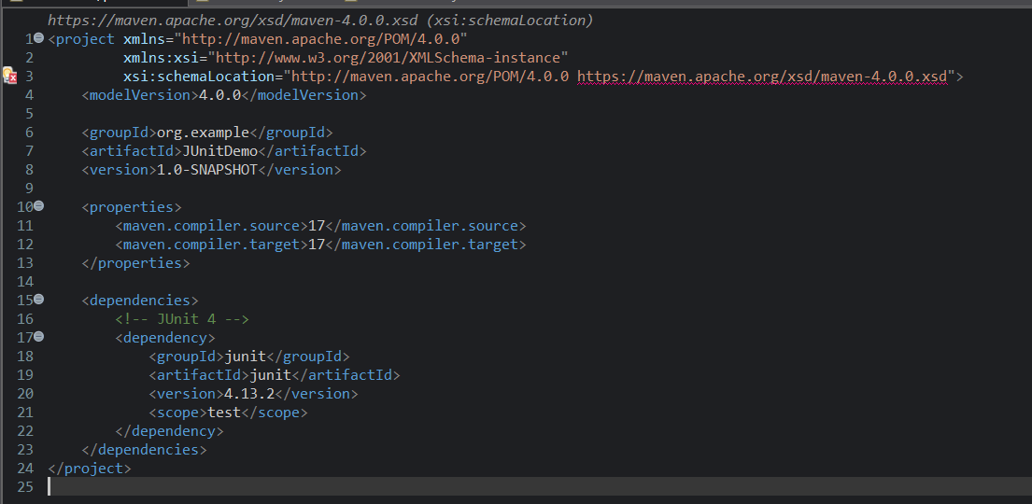

Caluculator.java

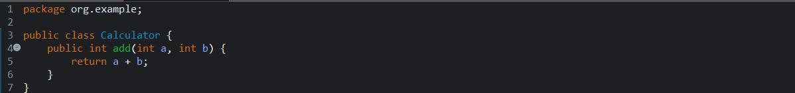

CaluculatorTest.java

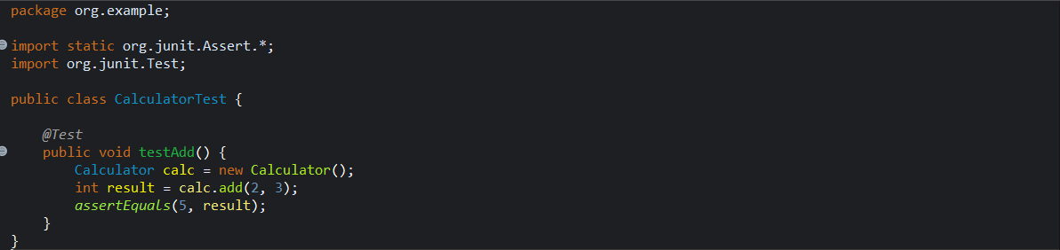

assesrtions

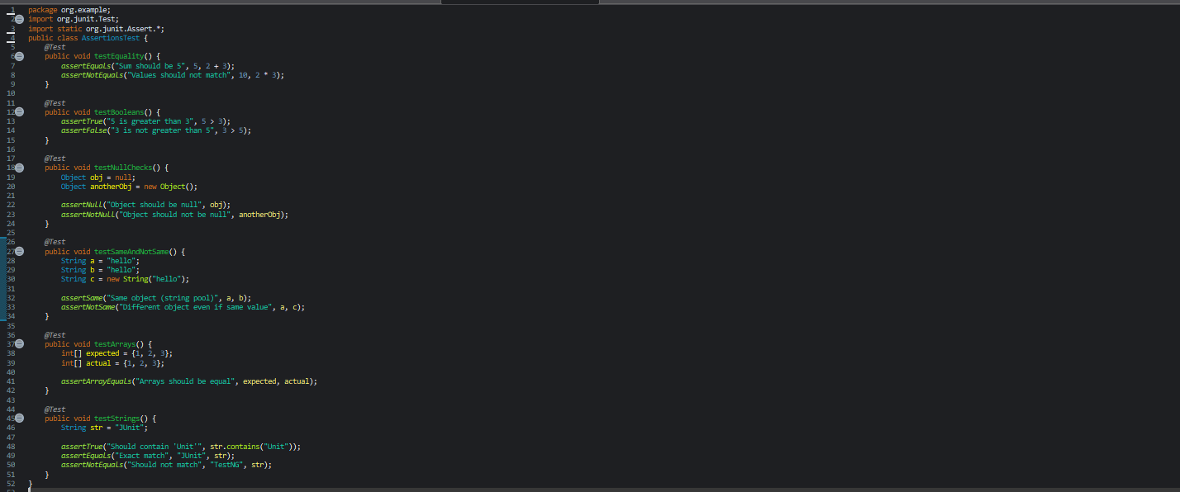

output: 